**Weekly Status Report - 2019-03-07**

|  |  |
| --- | --- |
| **Project Name** | ThinkFood |
| **Team Lead** | Jonghyun Choi |

|  |  |  |  |  |  |
| --- | --- | --- | --- | --- | --- |
| **Roles** |  |  |  |  |  |
| **Week** | **ChangSin Park** | **Qi Li** | **Rolando Pacho** | **Quang Pham** | **Jonghyun Choi** |
| 01 | DBA/Back-End developer | Front-End developer | Middle-ware developer | Front-End developer | Team Lead  Technical Writer |
| 02 | DBA/Back-End developer | Team Lead  Front-End developer | Middle-ware developer | Front-End developer | Technical Writer  DBA/Back-End developer |
|  |  |  |  |  |  |
|  |  |  |  |  |  |
|  |  |  |  |  |  |
|  |  |  |  |  |  |
|  |  |  |  |  |  |

|  |
| --- |
| **Weekly Project Summary** |
| * Defined the requirements from the client: Project Charter * Documented use specification: BRD * Planned the schedule and assigned the roles on each member: Gantt Chart * Preparation is completed for design |

|  |  |  |  |  |  |
| --- | --- | --- | --- | --- | --- |
| **Key Milestones Status** | | | | | |
| **ID** | **Description** | **Planned Completion** | **Forecasted**  **Completion** | **Actual Completion** | **Status** |
| 6 | Requirement is defined | 2019-03-06 | 2019-03-06 | 2019-03-07 | Closed |
| 5 | Project Charter | 2019-03-06 | 2019-03-06 | 2019-03-07 | Closed |
| 5 | BRD | 2019-03-06 | 2019-03-06 | 2019-03-07 | Closed |
| 3 | Gantt Chart | 2019-03-06 | 2019-03-06 | 2019-03-07 | Closed |
| 22 | Preparation for development | 2019-03-18 | 2019-03-18 |  |  |
| 7 | Web pages | 2019-03-18 | 2019-03-18 |  |  |
| 18 | Database Structure | 2019-03-13 | 2019-03-13 |  |  |
| 52 | Initial website | 2019-04-03 | 2019-04-03 |  |  |
| 57 | Tested website | 2019-04-10 | 2019-04-10 |  |  |
| 59 | Final Report with documents | 2019-04-11 | 2019-04-11 |  |  |
|  |  |  |  |  |  |
|  |  |  |  |  |  |
|  |  |  |  |  |  |
|  |  |  |  |  |  |
|  |  |  |  |  |  |

|  |
| --- |
| **Key Accomplishments for the Week** |
| * Requirements specification * Defined whole tasks for this project |

|  |  |  |  |  |  |
| --- | --- | --- | --- | --- | --- |
| **Task Assignments for the Coming Week** | | | | |  |
| **ID** | | **Description** | **Assigned To** | | **On Schedule** |
| 9 | | Draw diagrams | Quang, Rolando, Murphy | | Yes |
| 10 | | Prepare pictures | Murphy, Rolando | | Yes |
| 19 | | Create Entities | Jonghyun, Changsin | | Yes |
| 12 | | Create customer page | Rolando | | Yes |
| 13 | | Create restaurant page | Quang | | Yes |
| 14 | | Create administrator page | Changsin | | Yes |
| 20 | | Normalization | Jonghyun, Murphy | | Yes |
| 21 | | SQL script objects and create DB | Jonghyun, Murphy | | Yes |
|  | |  |  | |  |
|  | |  |  | |  |
| **Tasks Completed in the Previous Week** | | | |  | |
| **ID** | **Description** | | | **Assigned To** | |
| 2 | Requirements analysis | | | Jonghyun, Changsin, Rolando, Murphy, Quang | |
| 3 | Planning a schedule and roles | | | Jonghyun | |
| 4 | UML use case diagram | | | Quang, Rolando | |
| 5 | UML use case specification | | | Quang, Rolando, Changsin, Murphy | |
|  |  | | |  | |
|  |  | | |  | |
|  |  | | |  | |

|  |  |
| --- | --- |
| Issues and Risks |  |
| **Description** | **Impact**  **(L,M,H)** |
| Some schedule and roles could be changed to meet the requirements and due date | High |
| Some tasks could be missed at plan, all steps should be checked related tasks | High |
|  |  |

|  |
| --- |
| **Gantt Chart** |

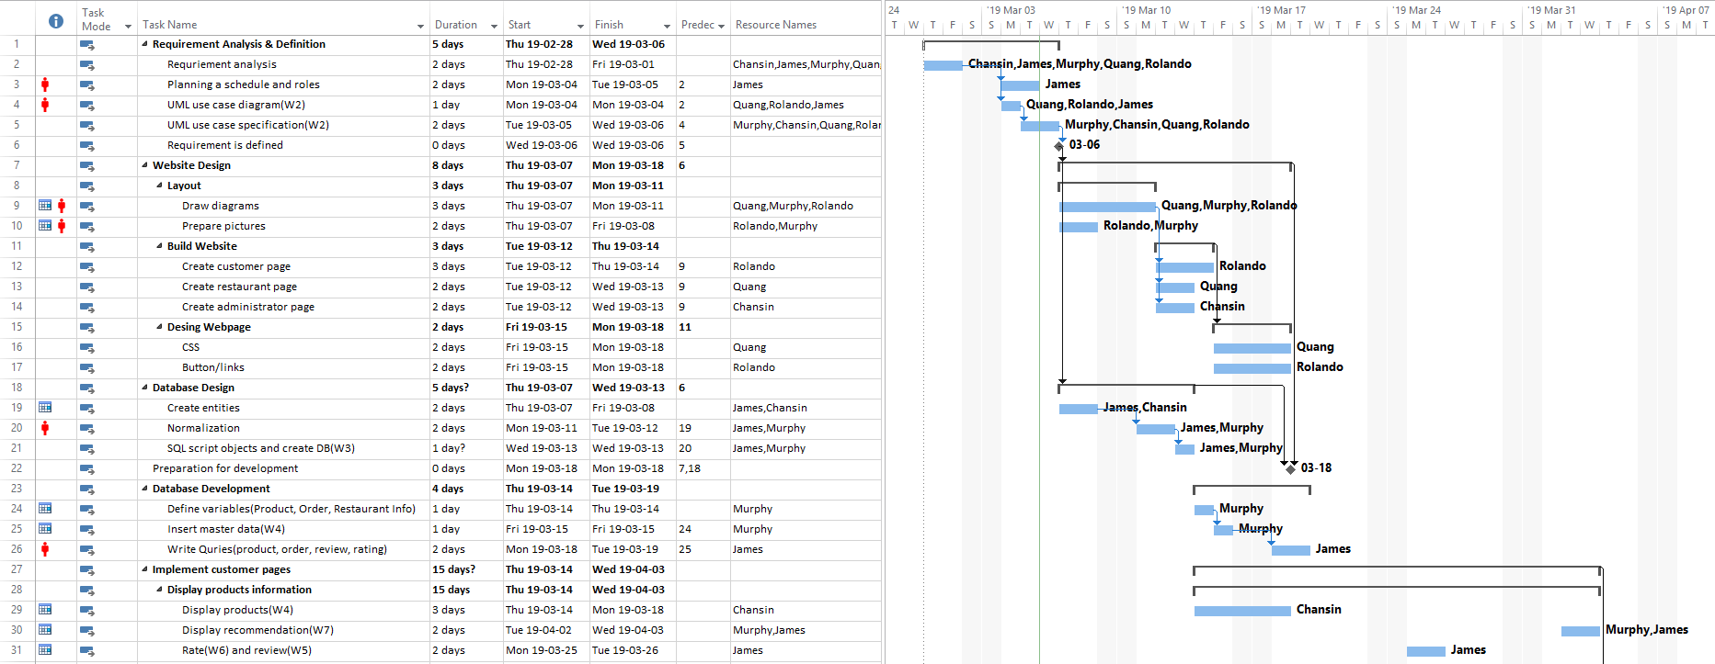

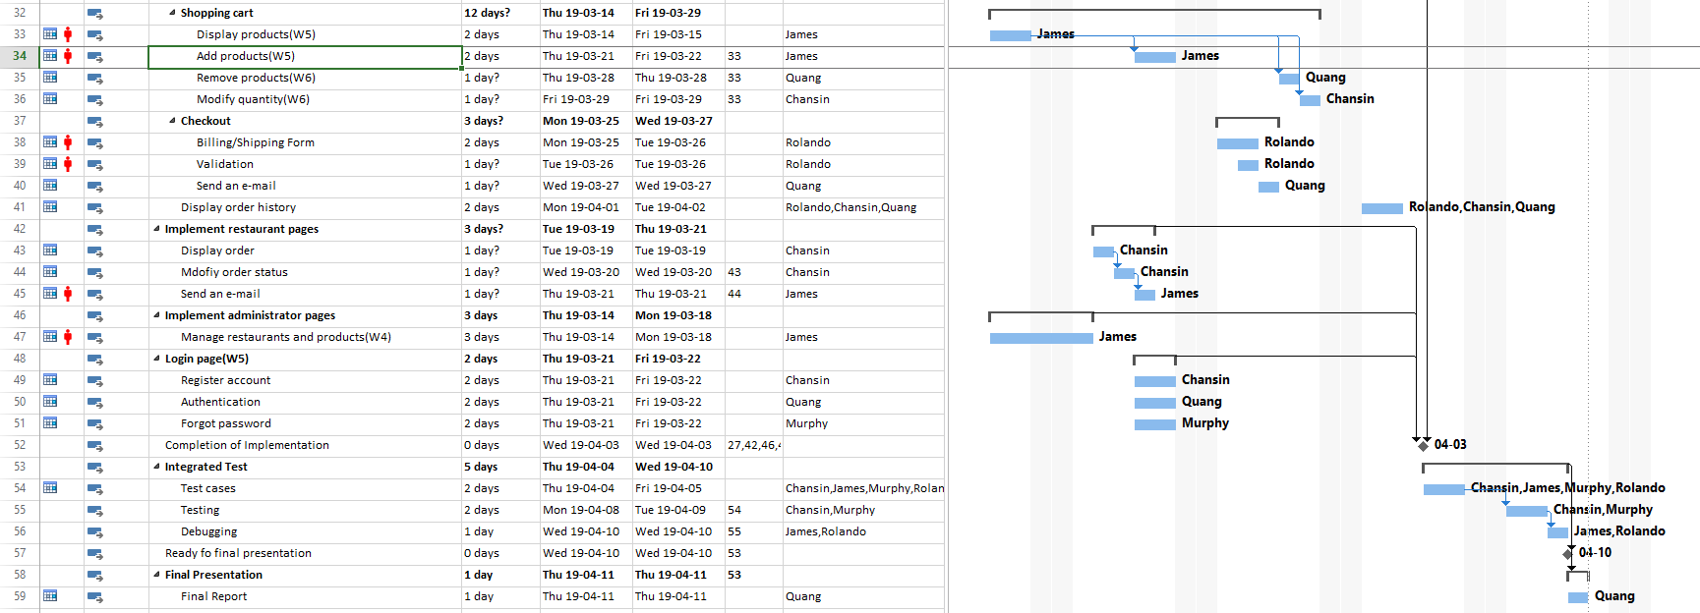

Figure 1. Gantt Chart

|  |
| --- |
| **Git Log** |

*< Insert Git Log here, use the following command*

*git log --since=1.week --pretty=format:"%an: %s"*

*>*